

**HTML Assignment -** Class 9

**Previous Class: Working with Multimedia Objects**

**Today Assignment: Making consistent layout using Template**

**Time: 30 minutes**

**Template requirement:**

**Pass requirement: 4 / 10 points**

1. Create a form as following:

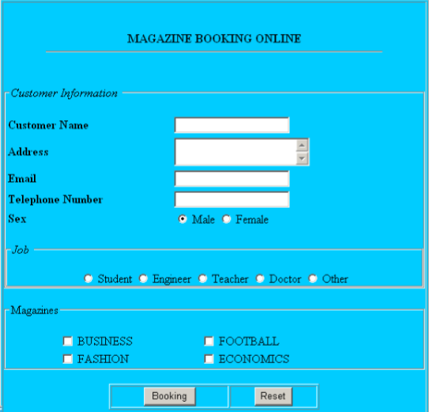

1. When user Click on Reset Button, all field must be cleared.
2. When user Click on Booking Button, following validations will be performed:
   1. All fields cannot be empty
   2. If user does not check any magazines, Message Box will display: “Please, choose at least one magazines”.
   3. Telephone Number is in form of can contains only number, - , and space
   4. Example: 84-4-5735999
   5. Email must in correct format. (Example: aptech@sun.com.uk)
3. If all validations are performed, an Message Box will be display with these information:

Thanks, [title] [Customer Name] – a [Job]

You are booking: [List of Magazines] magazine

**then this form will be submitted.**

*[title] depends on Sex. (Mr for Male and Mrs for Female)*

*[List of Magazines] depends on check of magazines.*

*[Job] : When user check Other, job is Reader.*

*Example:*

*Thanks, Mr Nguyen Van - a teacher*

*You are booking: Business, Football magazine.*